**Installing BMP180 Library**

We have an Arduino library for BMP180 which can be easily used to get the sensor readings. Now let’s see how to install this library in Arduino. This library is provided by Adafruit.

To install the library, we will use the Arduino Library Manager. Open your Arduino IDE and go to **Sketch > Include Libraries > Manage Libraries**. Type ‘adafruit bmp180’ in the search bar and install the latest version of the library highlighted below. Notice that it is the ‘AdafruitBMP085 Library’ which is used for both BMP085 and BMP180.

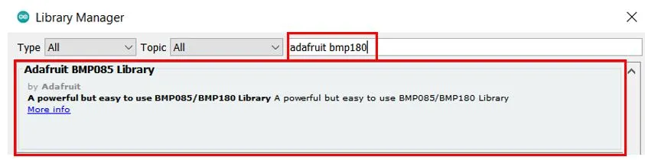

## Arduino Display BMP180 Temperature and Pressure Readings on OLED

In this section, we will see how to display the temperature and pressure readings of BMP180 on a 0.96 SSD1306 OLED display using Arduino IDE and Arduino.

### Installing SSD1306 OLED Library in Arduino IDE

To use the OLED display in our project, we have to install the Adafruit SSD1306 OLED library in Arduino IDE. Follow the steps below to successfully install it.

Open Arduino IDE and click on **Sketch > Library > Manage Libraries**. Type ‘SSD1306’ in the search tab and install the Adafruit SSD1306 OLED library.

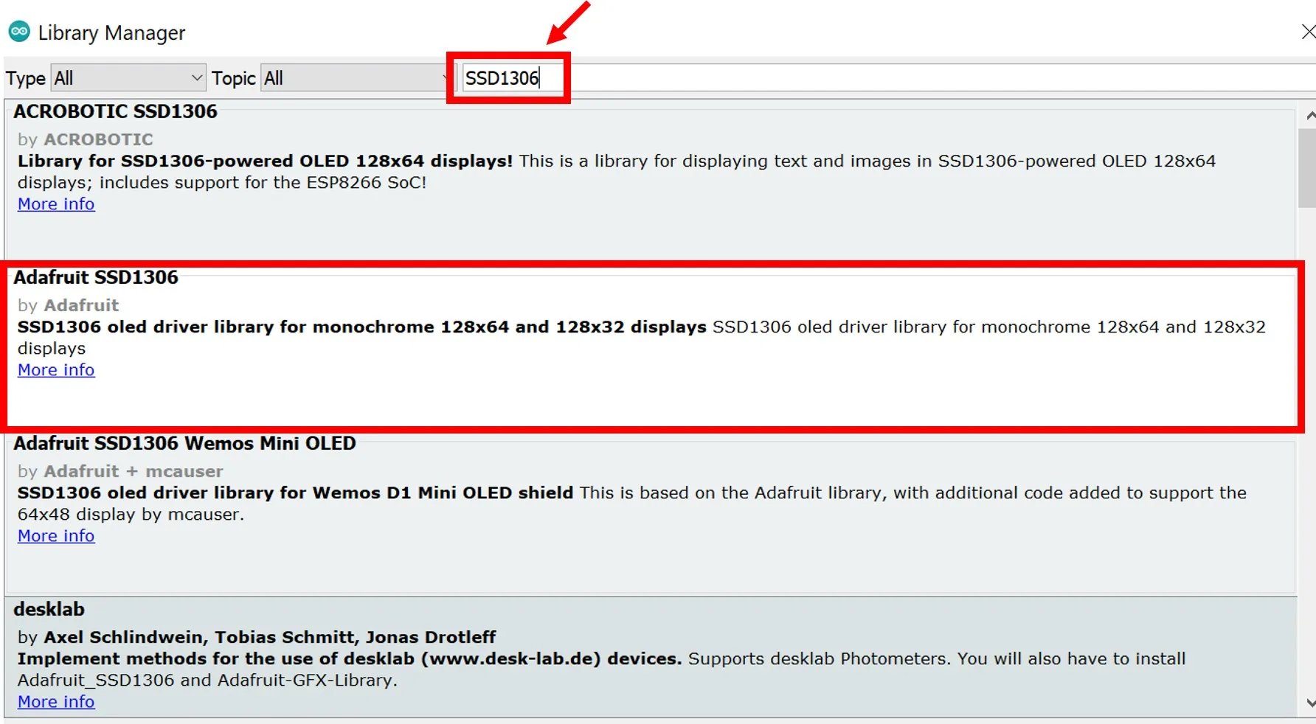

We will also require the Adafruit GFX library which is a dependency for SSD1306. Type ‘Adafruit GFX’ in the search tab and install it as well.

